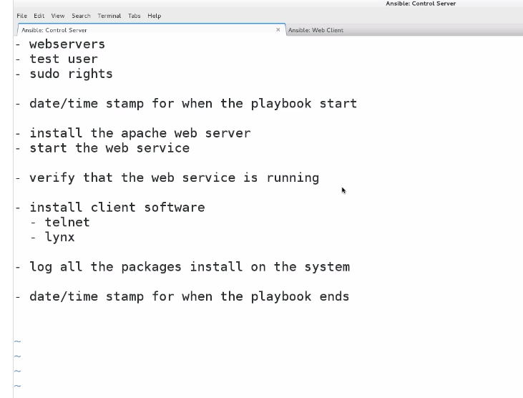

Now that we have seen a playbook, let's step back and develop a more complex one, explaining it a section at a time.

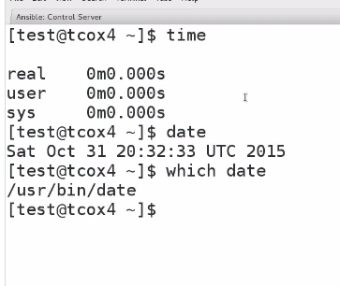

Now that we have seen a playbook, let's step back and develop a more complex one, explaining it a section at a time.

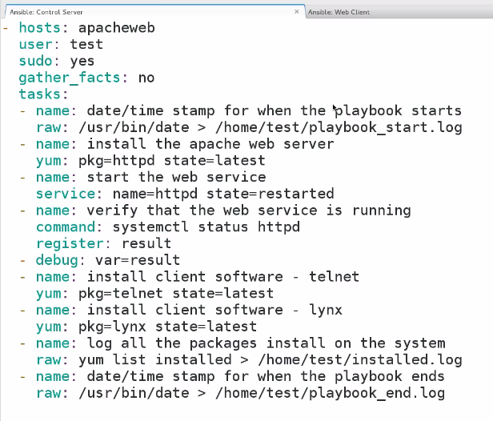

For checking before running playbook ..it will run or not ..we will use - -check

